Interaction Diagram

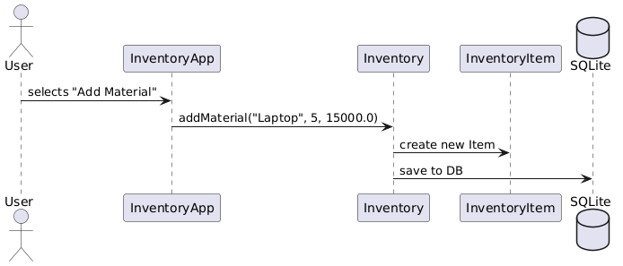

@startuml

actor User

participant InventoryApp

participant Inventory

participant InventoryItem

database "SQLite"

User -> InventoryApp : selects "Add Material"

InventoryApp -> Inventory : addMaterial("Laptop", 5, 15000.0)

Inventory -> InventoryItem : create new Item

Inventory -> SQLite : save to DB

@enduml